**DAILY ONLINE ACTIVITIES SUMMARY**

|  |  |  |  |  |  |  |  |  |
| --- | --- | --- | --- | --- | --- | --- | --- | --- |
| **Date:** | **03/06/2020** | | | | | **Name:** | **NAGASHREE ARUN M** | |
| **Sem & Sec** | **6th A** | | | | | **USN:** | **4AL17CS053** | |
| **Online Test Summary** | | | | | | | | |
| **Subject** | | **CGV IA Test - 3** | | | | | | |
| **Max. Marks** | | **30** | | **Score** | | |  | |
| **Certification Course Summary** | | | | | | | | |
| **Course** | **INTRODUCTION TO CLOUD COMPUTING** | | | | | | | |
| **Certificate Provider** | | | **Harvard University** | | **Duration** | | | **12weeks** |
| **Coding Challenges** | | | | | | | | |
| **Problem Statement:**  **1.DEMONSTRATE STAR PATTERN IN PYTHON.**  **2MERGE SORT PROBLEM** | | | | | | | | |
| **Status: Completed** | | | | | | | | |
| **Uploaded the report in GitHub** | | | | | **Yes** | | | |
| **If yes Repository name** | | | | | <https://github.com/neenaarun12345/daily-status/tree/master/31-05-20/online%20coding> | | | |
| **Uploaded the report in slack** | | | | | **Yes** | | | |

**Online Certification Detail**

**Lesson**

* Security

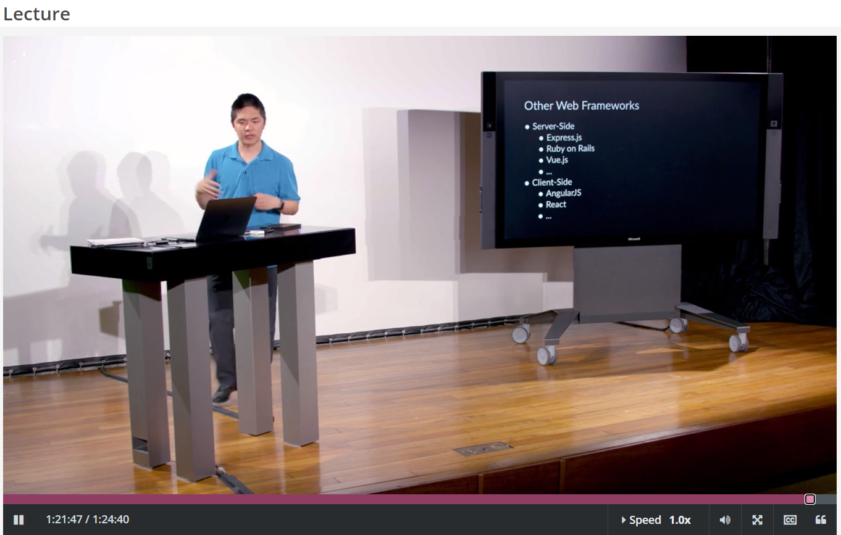

**Coding Challenge Details**

1. **DEMONSTRATE STAR PATTERN IN PYTHON:**

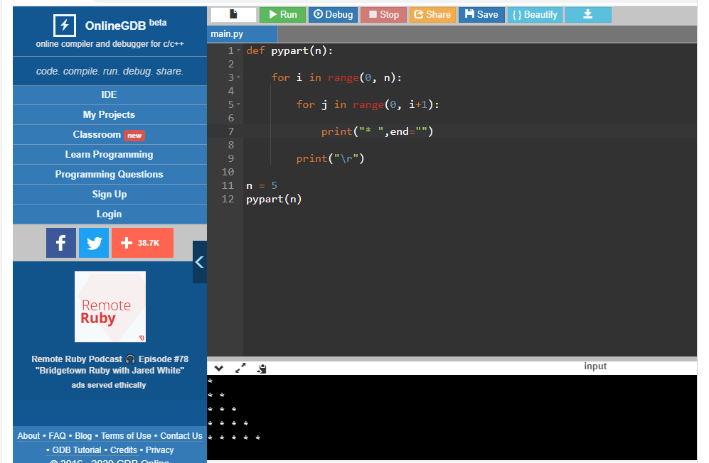

**2. MERGE SORT PROBLEM:**

